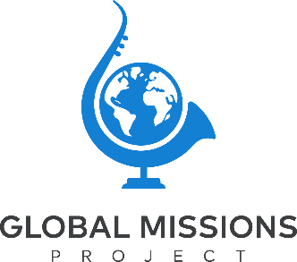

MONTH, DAY, YEAR

Dear NAME,

I am writing to share with you a wonderful opportunity that the Lord has provided for me. I have been asked to serve on a Music Mission Project to LOCATION! We will be working in partnership with Global Missions Project and local missionaries and Christian workers. The dates are MONTH, DAYS, YEAR and the cost is AMOUNT. The cost covers airfare, breakfast, accommodations, insurance, ground transportation, Project Development, and a Travel Leader. Each team member is responsible for raising 100% of their financial and prayer support.

We will be working with local Christian Leaders to support their ministry strategies and objectives. The primary objective of our work will be to share Christ with the people in the community and secondly, we will develop relationships with local musicians.

Please pray that God will prepare the hearts of the people to whom we will minister and that they will be open to hear the Gospel. Pray for the unity of our Mission Team and that each member will be open to learn all that God has to teach us. Also, pray that God would supply my financial need for this Mission Project.

Financial support is of course essential to my participation, but of equal or greater importance is your commitment to pray! If you would like to contribute financially, please make checks payable to Global Missions Project and put my name on the memo line. You can also contribute directly into my account by visiting globalmissionsproject.com/give. All contributions are tax deductible.

Thanks so much for your help and may God richly bless you!

In Christ,

NAME

All mailed contributions can be sent to:
Global Missions Project
2095 Exeter Rd
Suite 80-494
Germantown TN 38138

